RESULTS OF SQL QUERIES

PART 1- ETL Pipeline

- Query 1: Customer Purchase History
Generate a detailed report showing each customer's name, email, total number of orders placed, and total amount spent. Include only customers who have placed at least 2 orders and spent more than ₹5,000. Order by total amount spent in descending order.

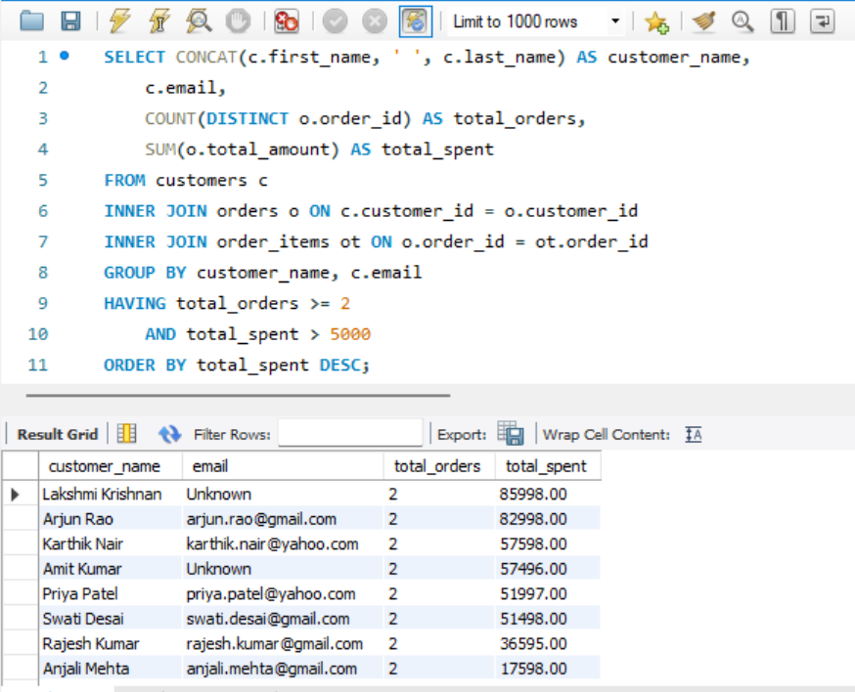

- Query 2: Product Sales Analysis
For each product category, show the category name, number of different products sold, total quantity sold, and total revenue generated. Only include categories that have generated more than ₹10,000 in revenue. Order by total revenue descending.
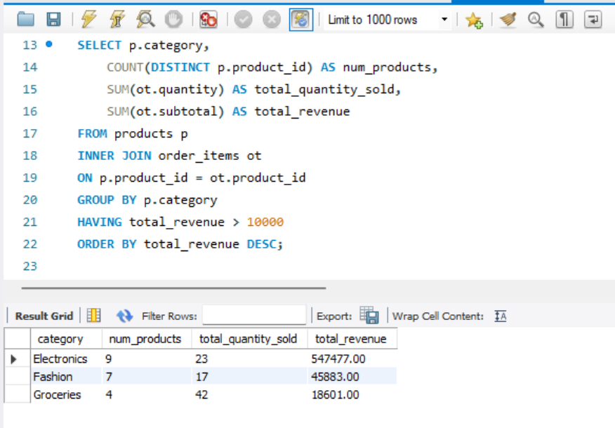

- Query 3: Monthly Sales Trend
Show monthly sales trends for the year 2024. For each month, display the month name, total number of orders, total revenue, and the running total of revenue (cumulative revenue from January to that month)
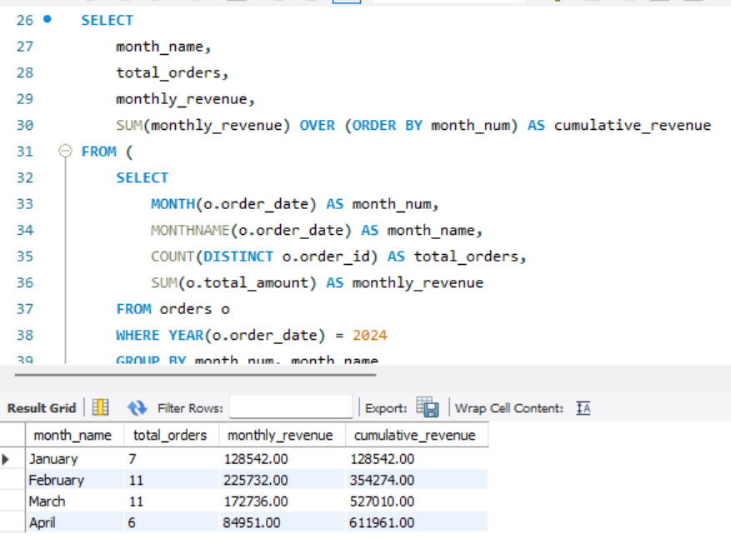

PART 3 - Star_Schema
- Query 1: Monthly Sales Drill-Down
The CEO wants to see sales performance broken down by time periods. Start with yearly total, then quarterly, then monthly sales for 2024.
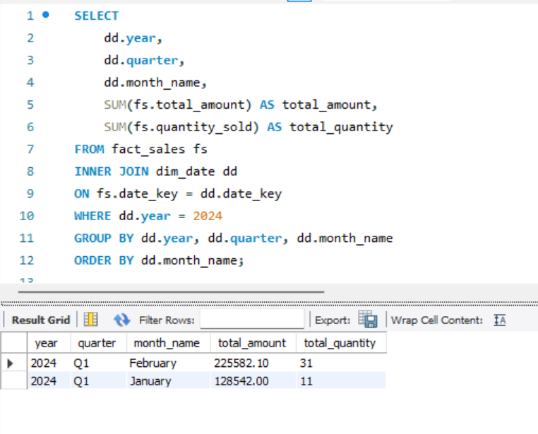

- Query 2: Top 10 Products by Revenue
The product manager needs to identify top-performing products. Show the top 10 products by revenue, along with their category, total units sold, and revenue contribution percentage.
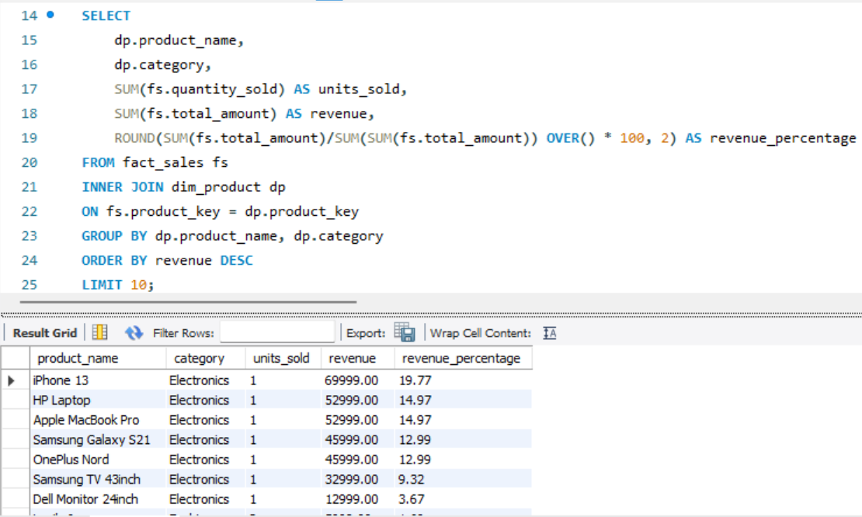

- Query 3: Customer Segmentation
Marketing wants to target high-value customers. Segment customers into 'High Value' (>₹50,000 spent), 'Medium Value' (₹20,000-₹50,000), and 'Low Value' (<₹20,000). Show count of customers and total revenue in each segment.

